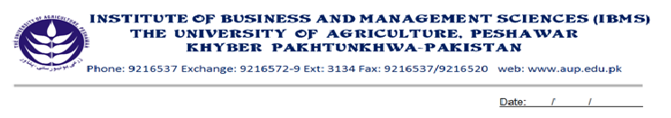
Programme: BS(CS)-V
Course Name: Modern Programming Languages-II
Course Code: CS-504
Session: 2010-2013
Course Hours: 03
Total Weeks: 16
Total Hours: 48

Course Objectives:
This course is continuation of the Modern Programming Language I Course, that student’s have already studied. This course will introduce students to work for the distributed/client/server environment using advanced Java GUI Technology, and databases. This will prepare them to enter the market with the expertise, which is considered necessary in their field.

Week-1
-Interfaces
-Defining an Interface
-Implementing an interface
-Applying Interfaces
-Variables in interfaces
-Extending Interfaces
-Interfaces & Multiple Inheritances

Week-2
-Java Applet & its Life Cycle
-Init() start() paint() stop() destroy()
-Adding Controls to Applets
-Button
-Text Field
-Label

Week-3
-Swings Introduction
-Swings Component Hierarchical structure
-Delegation Event Handling Model

Week-4
-Working with JApplet
-Creating JFrame

Week-5
-Working with JLabel
-JButton with event handling
-JTextField & JPasswordField

Week-6
- JCheck Box & JRadio Button with Event handling
- JCombo

Week-7
-Mouse Events
-Window Events

Week-8
-Understanding Multithreading
-Thread Basics

Week-9
-Thread Life Cycle
-Two ways of Thread Creation

Week-10
-Java Data Base Connectivity
-JDBC-ODBC Bridge working
-Creating DSN
-Connection, Statement, Result Set Object

Week-11
-Connection to Databases
-Performing database queries and DML through Java Program against DBMS
-Navigating through Multiple Rows retrieved from Database

Week 12
-Network Programming
-IP Packets and Logical Ports
-Connection Oriented vs Connectionless Communication(TCP/IP & UDP)
-Sockets

Week-13
-Inet Address Class
-Creating a client Program
-Creating a Server Program
-Communication b/w Client & Server

Week-14
-Remote Method Invocation
-RMI Architecture
-Client Application
-Client Stub
-Remote Reference Layer
-Transport Layer

Week-15
-Creating a complete RMI Application
1. Defining an Interface for Remote Object
- Implementing the Interface by Remote Object
- Binding Object to Registry Service

Week-16
- Creating Stub & Skeleton
- Create & Compile Client Program
- Running the RMI Application

Total Marks: 100

Recommended Books:
Web Application with Java By Ivon Byrose
Java2 the Complete Reference By Herbert Schildt
Java2 Swing By Deitel & Deitel

